CS 767 Advanced Machine Learning Homework 7
Joseph Rissman
U09545917
- Logic Gates. In class, we discussed that the XOR gate could be realized with a multi-layer feedforward network by observing that for any two binary inputs $X_{1}$ and $X_{2}$, $X_{1} XOR X_{2}=\left(X_{1} AND \left(NOT X_{2}\right)\right) OR \left(\left(NOT X_{1}\right) AND X_{2}\right)$. Draw the complete network for the XOR gate showing all weights and biases for each neuron in the network.
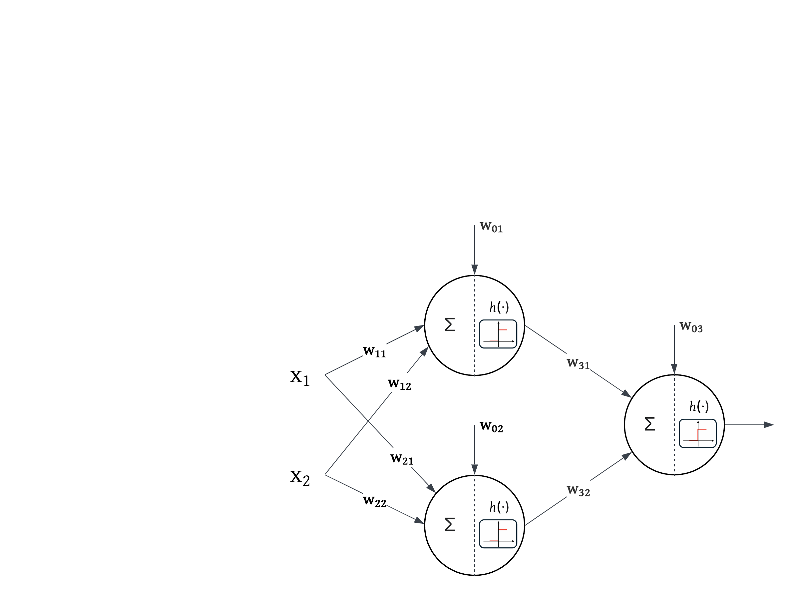
$w_{11}=1$ $w_{12}=-1$ $w_{01}=-0.5$
$w_{21}=-1$ $w_{22}=1$ $w_{02}=-0.5$
$w_{31}=1$ $w_{32}=1$ $w_{03}=-0.5$

- Three-input gates. Suppose I wish to implement $X_{1} AND X_{2} AND X_{3}$. Can I realize this gate using (a) two neurons each with 2 inputs and a bias, and (b) a single neuron with 3 inputs and a bias? Whenever possible, draw the network with all weights and activation functions.
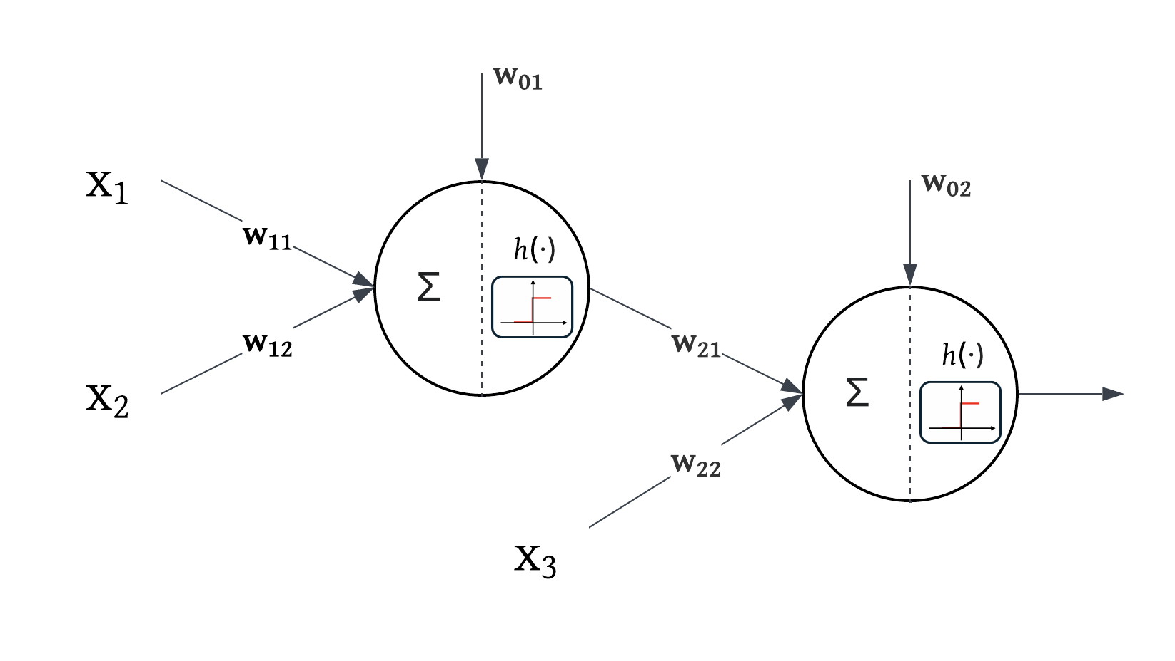
$w_{11}=1$ $w_{12}=1$ $w_{01}=-1.5$
$w_{21}=1$ $w_{22}=1$ $w_{02}=-1.5$

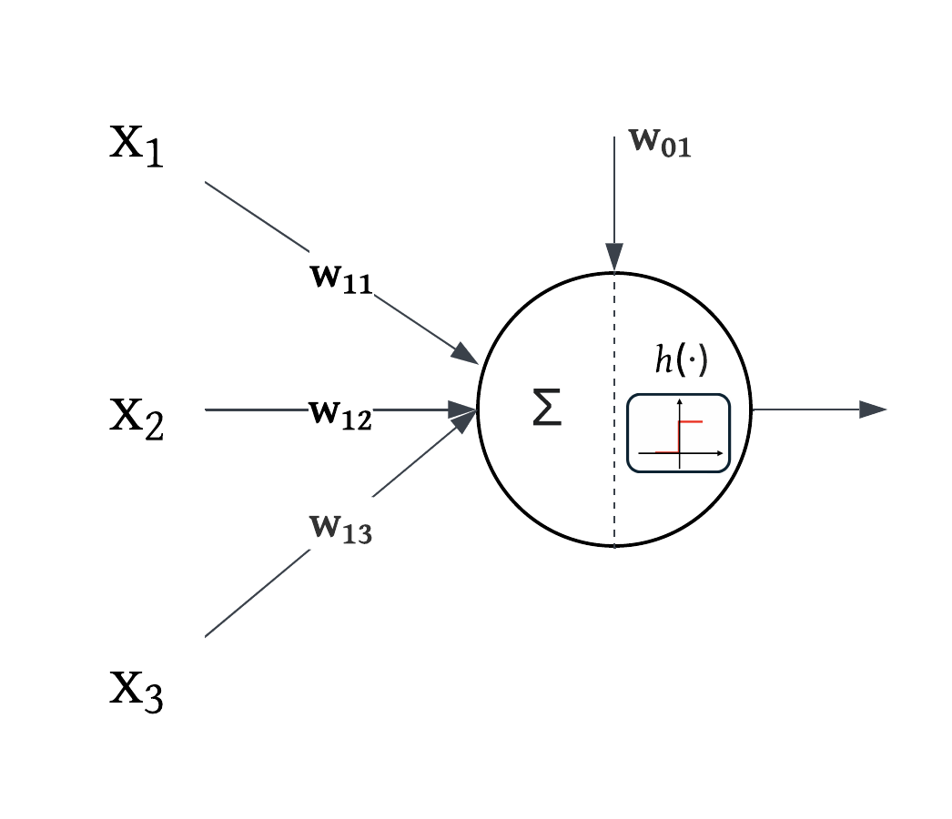
$w_{11}=1$ $w_{12}=1$ $w_{13}=1$ $w_{01}=-2.5$

- Bagging. In this exercise, we will numerically estimate the probability that a given observation is part of a bootstrap sample (reference: Sec. 5.2 and 5.4, ISLP).
  - Generate a set 𝒟 of $n=1,000$ random Gaussian observations and tag observation $j=4$. Generate 200 bootstrapped samples $D^{(i)}, i=1, 2, …, 200$, from this set and find the fraction of bootstrapped samples that do not contain the tagged observation.
  - Using the above procedure, create a plot that displays, for each integer value 𝑛 from 100 to $100,000$, the fraction of bootstrapped samples that contain the tagged $(j^{th})$ observation.
  - Given that $\lim_{n→∞}{{\left(1-\frac{1}{n}\right)}^{n}=\frac{1}{e}}$, comment on what your plot in Part b. above looks like in for large values of $n$.
- Boosting. Complete the Scikit-Learn exercise on using the AdaBoost Classifier.

